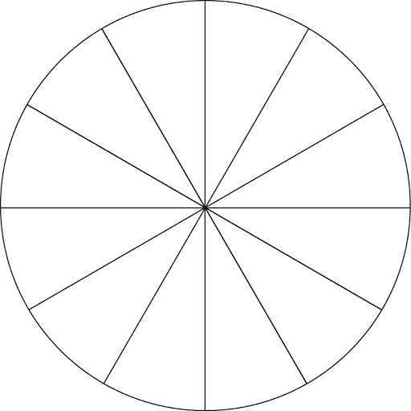

National Origin

2

Religion/

Spirituality 5

Mental Health 1 3 4

Physical (Dis)Ability

Sexual Orientation

Greek (Non)Affiliation

Political (Non)Affiliation

Socioeconomic Status

Gender 3

Race/Ethnicity

Body Size/Shape

Age

# Instructions for completing the social identity wheel:

* Place a ‘1’ in the section(s) of the wheel that lists the identity that you think about *most* often
* Place a ‘2’ in the section(s) of the wheel that lists the identity that you think about *least* often
* Place a ‘3’ in the section(s) of the wheel that you think has the strongest effect on how *other people see you*
* Place a ‘4’ in the section(s) of the wheel that you think has the strongest effect on how *you see yourself*
* Place a ‘5’ in the section(s) of the wheel that you feel *defined you most when you were growing up*
* Place a ‘6’ in the section(s) of the wheel that you feel *defines you most now*
  + This would be my photography and videography